School District No. 43 (Coquitlam)
Learning Services
1100C Winslow Avenue, Coquitlam, B.C., V3J 2G3
Tel: (604) 937-6386 Virtual Fax: (604) 937-8061

“To provide specialized services to increase success for diverse learners”

MEMORANDUM
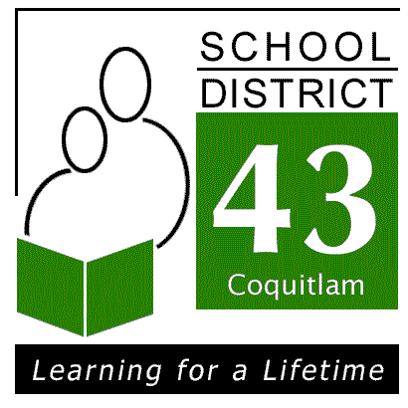

January 8th, 2015

Dear Parents/Guardians,
School District 43 and Simon Fraser Society for Community Living would like to invite and encourage you to attend an information session “It’s Time to Talk about Middle School”. This is an opportunity for you to gather important information regarding middle school, the transition process, and what you can do as a parent to prepare yourself and your child for middle school.
At this session you will have an opportunity to hear from middle school administrators from a variety of schools across the district. They will share general information about middle school and support services for students with intellectual or developmental disabilities at the middle level. You will be given a “Parent Handbook” for you to keep and use as you prepare for the transition to middle school.
We hope to see you at this very important information session.

Middle School Parent Information Evening
Tuesday, January 20th, 2015
6:30 p.m. – 8:30 p.m.
The Gallery Room at Winslow Centre
1100 Winslow Avenue, Coquitlam
(just west of Gatensbury)

Please RSVP to Simon Fraser Society for Community Living at info@sfscl.org or call 604-525-9494 by January 13th, 2015.

